Stereolithographic Additive Manufacturing of Zirconia Electrodes with Dendritic Patterns for Aluminum Smelting

Masaya TAKAHASHI*, Soshu KIRIHARA**
* Graduate School of Engineering, Osaka University; masaya-takahashi@jwri.osaka-u.ac.jp
** Joining and Welding Research Institute, Osaka University; kirihara@jwri.osaka-u.ac.jp

KEY WORDS: (additive manufacturing), (yttria stabilized zirconia), (aluminum smelting)

1. Introduction
High-temperature ceramics of yttria (Y₂O₃)-doped zirconia (ZrO₂) exhibit effective ion conductivities through substitutional solid solutions of low-valence cations [1]. Solid electrolytes of yttria-stabilized zirconia (YSZ) have been developed for practical applications in solid oxide fuel cells (SOFCs) [2].
Recently, YSZ electrodes have been used in the molten salt electrolysis of aluminum [3]. Metal anodes coated with fine YSZ layers attract oxygen ions in molten alumina, which are absorbed and released as oxygen gas. Metallic aluminum is deposited at the cathode. In conventional electrolysis, carbon anodes are used, resulting in the release of carbon dioxide. The use of YSZ electrodes for metal refining is a promising method to reduce greenhouse gas production. In this study, electrodes made of YSZ micro-lattices with ordered porosities were fabricated.

2. Experimental Procedure
Dendritic electrodes were designed by 3D-CAD software. The aspect ratio of the diameter and height of lattice struts was varied to obtain the values for maximum specific surface area of 4, 6, 8, and 12 coordination lattice configurations. The Finite Element Method (FEM) was used to simulate the pressure and temperature distribution on the surface and inside the connected lattices.
The slurry was prepared by mixing YSZ and photo-curable resin to achieve a solid content of 45 vol%. A 355 nm UV laser with 50 μm focal diameter was used to scan a 1 mm diameter hole in the center of a 5 × 5 mm square at a scan speed of 2000 mm/s, and laser power of 50-250 mW on a 3 mm thick slurry layer. Observation by digital optical microscopy allowed measurement of the curing depth and surplus width to determine optimal process parameters.
Solid parts were successfully fabricated by STL-AM through photopolymerization of part cross-sections by selective laser scanning of each layer. The resulting composite precursors were dewaxed and sintered at 1400 ºC in air for 2 hours. The relative density was measured using the Archimedes method and the lattice microstructure was observed by Scanning Electron Microscopy (SEM).

3. Results and Discussion
The maximum specific surface areas were obtained at aspect ratios of 1.17, 0.90, 2.34, and 2.18 for 4, 6, 8, and 12 configurations, respectively. The results of Computer Fluid Dynamics (CFD) analysis showed that the 12-coordination structure had the most evenly distributed flow paths across the electrode surface and the highest wettability (Fig. 1). The temperature distribution in the cross-section perpendicular to the fluid flow direction was visualized, showing marginally higher temperatures at the lattice surface than within.
12-coordination lattices were fabricated according to the designed model. The linear and volumetric shrinkage after sintering were estimated to be 25% and 60%, respectively, and were fed back into the model design to obtain the intended part dimensions. As a result, the accuracy of the final part was improved to ±10 μm, which was confirmed by measurement with digital calipers. Observation by SEM of a cross-section of the YSZ lattice revealed a fine ceramic structure without microcracks or pores. The relative density was confirmed to be 99.5%.

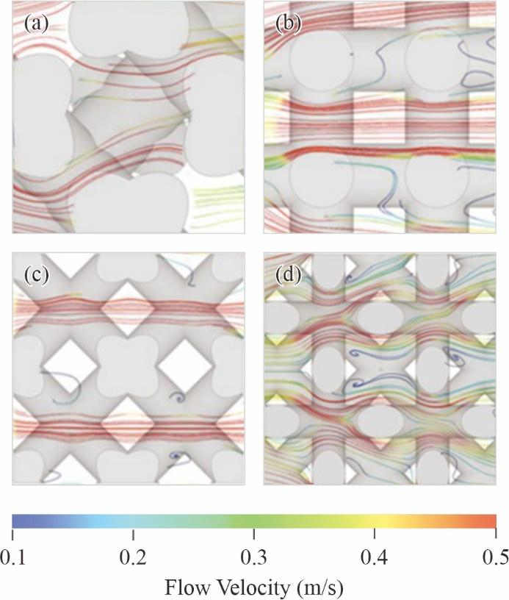
Fig. 1 CFD simulation of high temperature liquid streamline distributions in lattices of 4-, 6-, 8-, and 12-coordination (a-d respectively).

References
- S.J. Skinner, J.A. Kilner, Oxygen Ion Conductors, Materials Today. 6 (2003) 30-37.
- M.A. Janney, C.L. Calhoun, H.D. Kimrey, Microwave Sintering of Solid Oxide Fuel Cell Materials: I, Zirconia 8 mol% Yttria, Journal of the American Ceramic Society. 75 (1992) 341-346.
- S. Su, U. Pal, X. Guan, Solid Oxide Membrane Electrolysis Process for Aluminum Production: Experiment and Modeling, The Electrochemical Society. 16 (2017) 248-255.

